CREATE DATABASE bad_bankingdb;
USE bad_bankingdb;

CREATE TABLE account_file (
account_id INT PRIMARY KEY AUTO_INCREMENT,
customer_id VARCHAR(20) NOT NULL,
customer_name VARCHAR(100) NOT NULL,
address VARCHAR(255) NOT NULL,
phone VARCHAR(30),
account_type VARCHAR(50),
balance DECIMAL(12,2)
);

CREATE TABLE loan_file (
loan_id INT PRIMARY KEY AUTO_INCREMENT,
customer_id VARCHAR(20) NOT NULL,
customer_name VARCHAR(100) NOT NULL,
address VARCHAR(255) NOT NULL,
phone VARCHAR(30),
loan_type VARCHAR(50),
loan_amount DECIMAL(12,2),
outstanding_amount DECIMAL(12,2)
);
CREATE TABLE credit_card_file (
card_id INT PRIMARY KEY AUTO_INCREMENT,
customer_id VARCHAR(20) NOT NULL,
customer_name VARCHAR(100) NOT NULL,
address VARCHAR(255) NOT NULL,
phone VARCHAR(30),
card_number VARCHAR(30),
card_type VARCHAR(50),
credit_limit DECIMAL(12,2)
);

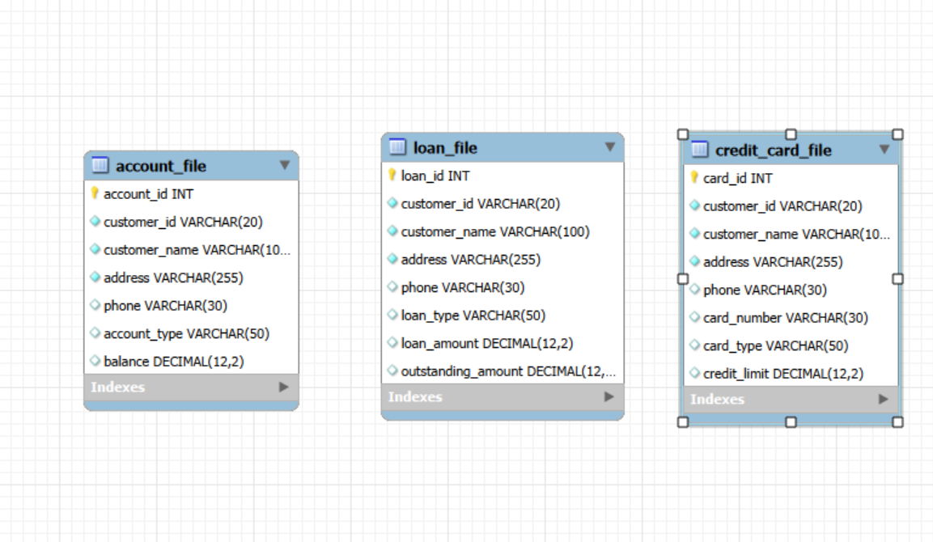

INSERT INTO account_file
(customer_id, customer_name, address, phone, account_type, balance)
VALUES
('C001', 'Aung Aung', 'No.10, Pyay Road, Yangon', '09-111111111', 'Savings',
500000.00),
('C002', 'Su Su', 'No.22, Hledan Street, Yangon', '09-222222222', 'Current',
1200000.00),
('C003', 'Kyaw Kyaw', 'No.45, Mandalay Road, Mandalay', '09-333333333',
'Savings', 300000.00);

SELECT * FROM account_file;
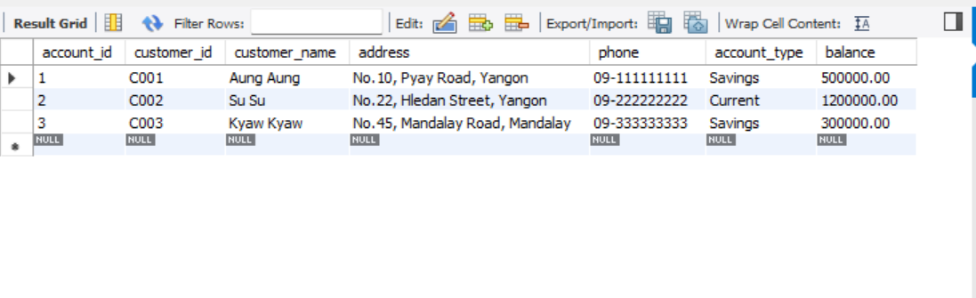
INSERT INTO loan_file
(customer_id, customer_name, address, phone, loan_type, loan_amount,
outstanding_amount)
VALUES
('C001', 'Aung Aung', 'No.10, Pyay Road, Yangon', '09-111111111', 'Home Loan',
10000000.00, 7500000.00),
('C002', 'Su Su', 'No.22, Hledan Street, Yangon', '09-222222222', 'Car Loan',
5000000.00, 2000000.00);

SELECT * FROM loan_file;
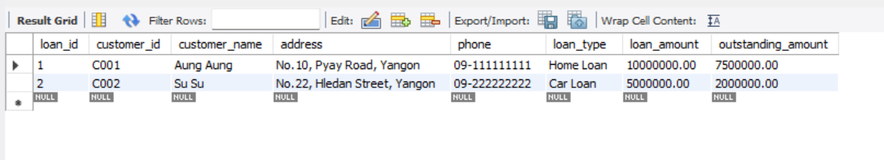

INSERT INTO credit_card_file
(customer_id, customer_name, address, phone, card_number, card_type,
credit_limit)
VALUES
('C001', 'Aung Aung', 'No.10, Pyay Road, Yangon', '09-111111111',
'4111111111111111', 'Gold', 2000000.00),
('C003', 'Kyaw Kyaw', 'No.45, Mandalay Road, Mandalay', '09-333333333',
'4222222222222222', 'Classic', 1000000.00);

SELECT * FROM credit_card_file;

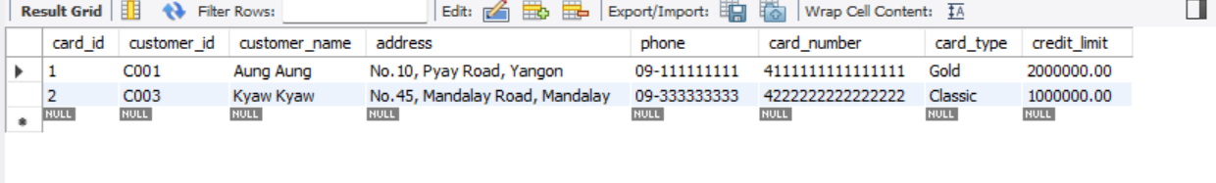

SET SQL_SAFE_UPDATES = 0;
UPDATE account_file
SET address = 'No.99, Inya Road, Yangon'
WHERE customer_id = 'C001';

SELECT * FROM account_file;

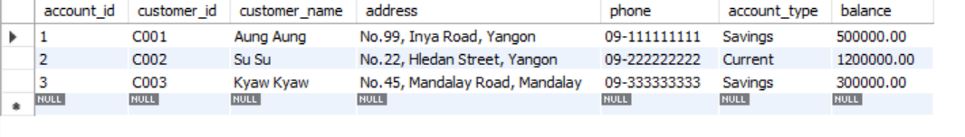
-- Check inconsistency
SELECT 'ACCOUNT FILE' AS source, customer_id, customer_name, address
FROM account_file
WHERE customer_id = 'C001'
UNION ALL
SELECT 'LOAN FILE' AS source, customer_id, customer_name, address
FROM loan_file
WHERE customer_id = 'C001'
UNION ALL
SELECT 'CREDIT CARD FILE' AS source, customer_id, customer_name, address
FROM credit_card_file
WHERE customer_id = 'C001';

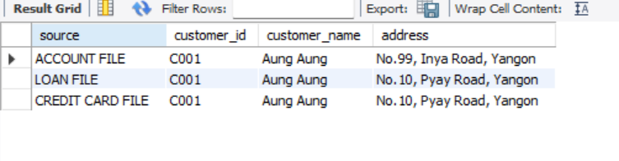
CREATE DATABASE good_bankingdb;

USE good_bankingdb;

CREATE TABLE customers (
customer_id VARCHAR(20) PRIMARY KEY,
customer_name VARCHAR(100) NOT NULL,
address VARCHAR(255) NOT NULL,
phone VARCHAR(30),
email VARCHAR(100),
created_at TIMESTAMP DEFAULT CURRENT_TIMESTAMP
);

CREATE TABLE accounts (
account_id INT PRIMARY KEY AUTO_INCREMENT,
customer_id VARCHAR(20) NOT NULL,
account_type VARCHAR(50) NOT NULL,
balance DECIMAL(12,2) NOT NULL DEFAULT 0,
opened_date DATE,
CONSTRAINT fk_accounts_customer
FOREIGN KEY (customer_id) REFERENCES customers(customer_id)
ON UPDATE CASCADE
ON DELETE RESTRICT
);

CREATE TABLE loans (
loan_id INT PRIMARY KEY AUTO_INCREMENT,
customer_id VARCHAR(20) NOT NULL,
loan_type VARCHAR(50) NOT NULL,
loan_amount DECIMAL(12,2) NOT NULL,
outstanding_amount DECIMAL(12,2) NOT NULL,
start_date DATE,
CONSTRAINT fk_loans_customer
FOREIGN KEY (customer_id) REFERENCES customers(customer_id)
ON UPDATE CASCADE
ON DELETE RESTRICT
);

CREATE TABLE credit_cards (
card_id INT PRIMARY KEY AUTO_INCREMENT,
customer_id VARCHAR(20) NOT NULL,
card_number VARCHAR(30) NOT NULL UNIQUE,
card_type VARCHAR(50),
credit_limit DECIMAL(12,2),
expiry_date DATE,
CONSTRAINT fk_cards_customer
FOREIGN KEY (customer_id) REFERENCES customers(customer_id)
ON UPDATE CASCADE
ON DELETE RESTRICT
);
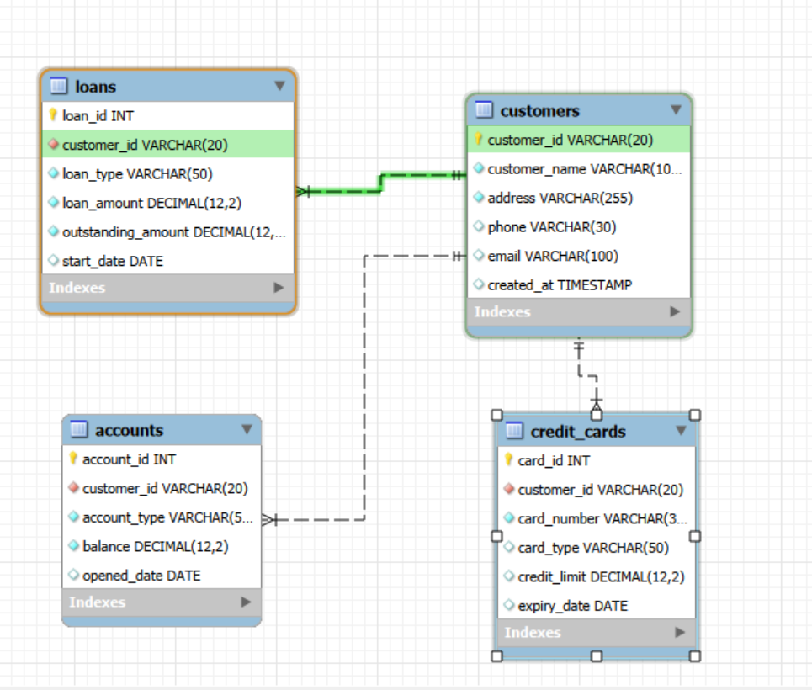

INSERT INTO customers
(customer_id, customer_name, address, phone, email)
VALUES
('C001', 'Aung Aung', 'No.10, Pyay Road, Yangon', '09-111111111',
'aung@example.com'),
('C002', 'Su Su', 'No.22, Hledan Street, Yangon', '09-222222222',
'susu@example.com'),
('C003', 'Kyaw Kyaw', 'No.45, Mandalay Road, Mandalay', '09-333333333',
'kyaw@example.com');

SELECT * FROM customers;
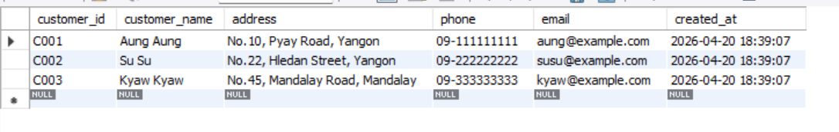
INSERT INTO accounts
(customer_id, account_type, balance, opened_date)
VALUES
('C001', 'Savings', 500000.00, '2024-01-10'),
('C002', 'Current', 1200000.00, '2024-02-15'),
('C003', 'Savings', 300000.00, '2024-03-01');

SELECT * FROM accounts;
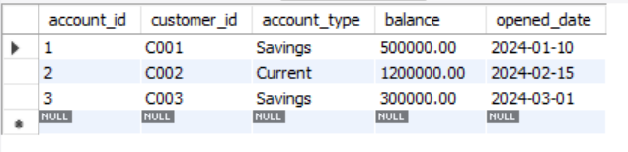
INSERT INTO loans
(customer_id, loan_type, loan_amount, outstanding_amount, start_date)
VALUES
('C001', 'Home Loan', 10000000.00, 7500000.00, '2024-04-01'),
('C002', 'Car Loan', 5000000.00, 2000000.00, '2024-05-10');

SELECT * FROM loans;
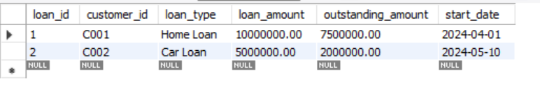
INSERT INTO credit_cards
(customer_id, card_number, card_type, credit_limit, expiry_date)
VALUES
('C001', '4111111111111111', 'Gold', 2000000.00, '2028-12-31'),
('C003', '4222222222222222', 'Classic', 1000000.00, '2027-11-30');

SELECT * FROM credit_cards;
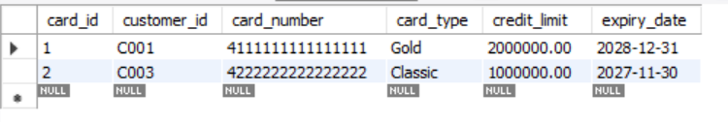

UPDATE customers
SET address = 'No.99, Inya Road, Yangon'
WHERE customer_id = 'C001';

SELECT * FROM customers;
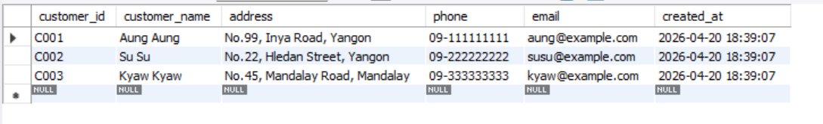

SELECT
c.customer_id,
c.customer_name,
c.address,
a.account_type,
a.balance,
l.loan_type,
l.outstanding_amount,
cc.card_number,
cc.card_type
FROM customers c
LEFT JOIN accounts a ON c.customer_id = a.customer_id
LEFT JOIN loans l ON c.customer_id = l.customer_id
LEFT JOIN credit_cards cc ON c.customer_id = cc.customer_id
WHERE c.customer_id = 'C001';

--View for Easy Demostration

CREATE VIEW vw_customer_banking_profile AS
SELECT
c.customer_id,
c.customer_name,
c.address,
c.phone,
a.account_id,
a.account_type,
a.balance,
l.loan_id,
l.loan_type,
l.loan_amount,
l.outstanding_amount,
cc.card_id,
cc.card_number,
cc.card_type,
cc.credit_limit
FROM customers c
LEFT JOIN accounts a ON c.customer_id = a.customer_id
LEFT JOIN loans l ON c.customer_id = l.customer_id
LEFT JOIN credit_cards cc ON c.customer_id = cc.customer_id;

SELECT * FROM vw_customer_banking_profile WHERE customer_id = 'C001';

--Test Cases
--Reset old data for C001

USE bad_bankingdb;

UPDATE account_file
SET address = 'No.10, Pyay Road, Yangon'
WHERE customer_id = 'C001';

SELECT * FROM account_file;
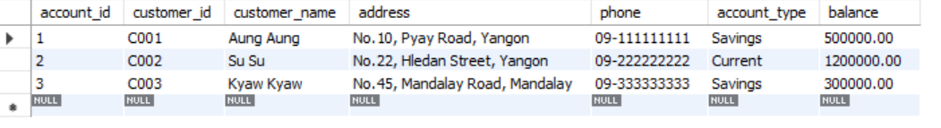

UPDATE loan_file
SET address = 'No.10, Pyay Road, Yangon'
WHERE customer_id = 'C001';

SELECT * FROM loan_file;
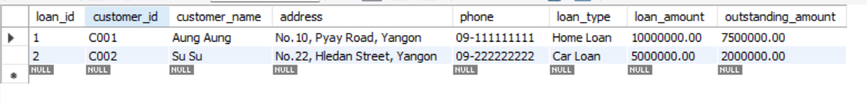

UPDATE credit_card_file
SET address = 'No.10, Pyay Road, Yangon'
WHERE customer_id = 'C001';

SELECT * FROM credit_card_file;
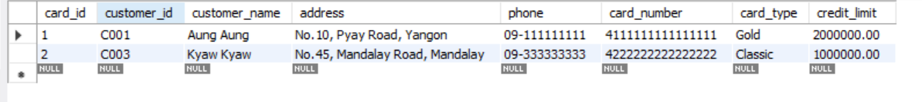

-- Update only account file

UPDATE account_file
SET address = 'No.99, Inya Road, Yangon'
WHERE customer_id = 'C001';

SELECT * FROM account_file;
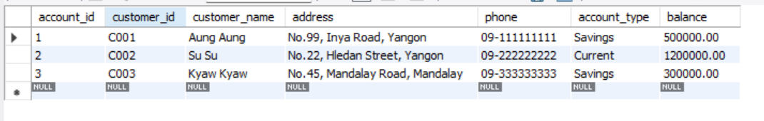

-- Verify inconsistency
SELECT 'ACCOUNT FILE' AS source, address
FROM account_file
WHERE customer_id = 'C001'
UNION ALL
SELECT 'LOAN FILE' AS source, address
FROM loan_file
WHERE customer_id = 'C001'
UNION ALL
SELECT 'CREDIT CARD FILE' AS source, address
FROM credit_card_file
WHERE customer_id = 'C001';

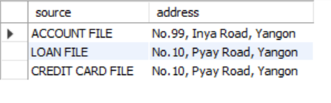
-- Test Case 2: Consistency in DBMS design
USE good_bankingdb;

-- Reset centralized data
UPDATE customers
SET address = 'No.10, Pyay Road, Yangon'
WHERE customer_id = 'C001';

SELECT * FROM customers;
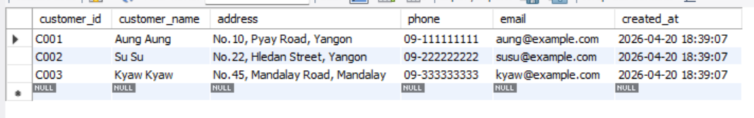
-- Update once
UPDATE customers
SET address = 'No.99, Inya Road, Yangon'
WHERE customer_id = 'C001';

SELECT * FROM customers;
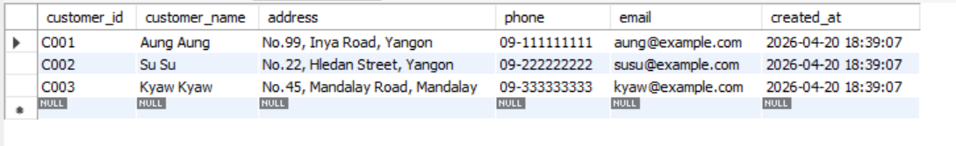

-- Verify consistency
SELECT
c.customer_id,
c.customer_name,
c.address,
a.account_type,
l.loan_type,
cc.card_type
FROM customers c
LEFT JOIN accounts a ON c.customer_id = a.customer_id
LEFT JOIN loans l ON c.customer_id = l.customer_id
LEFT JOIN credit_cards cc ON c.customer_id = cc.customer_id
WHERE c.customer_id = 'C001';
